- Create VPC with 2 private and 2 public subnets.
Login in into AWS and Navigate to VPC, create Vpc click on vpc only and a name to Vpc and give Ip address and click on create Vpc.
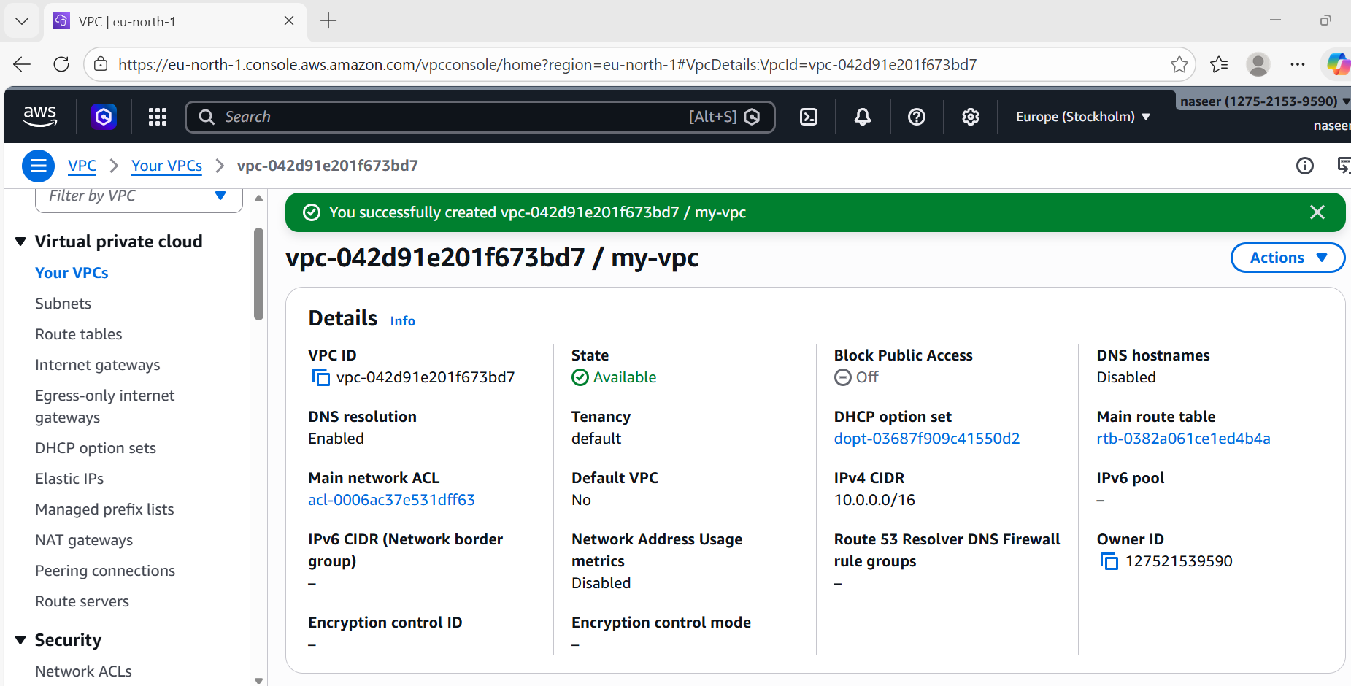

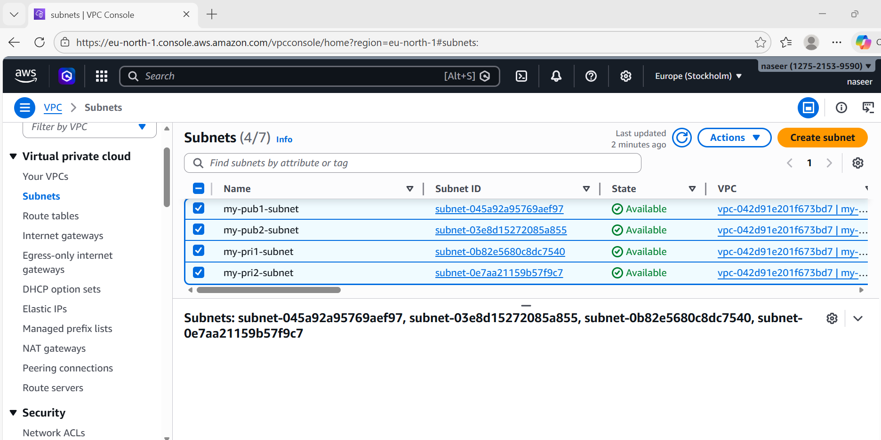

- Enable DNS Hostname in VPC.
Login into AWS and Navigate to VPC and select actions, edit Vpc settings and enable DNS hostname and save.
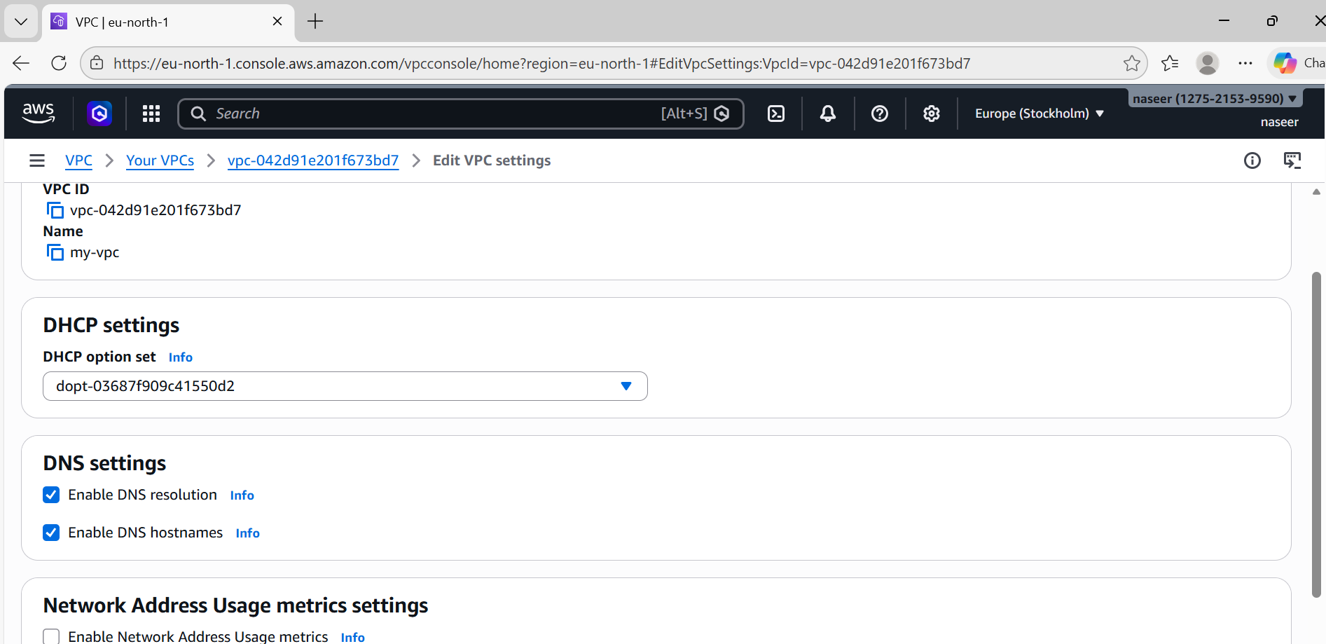

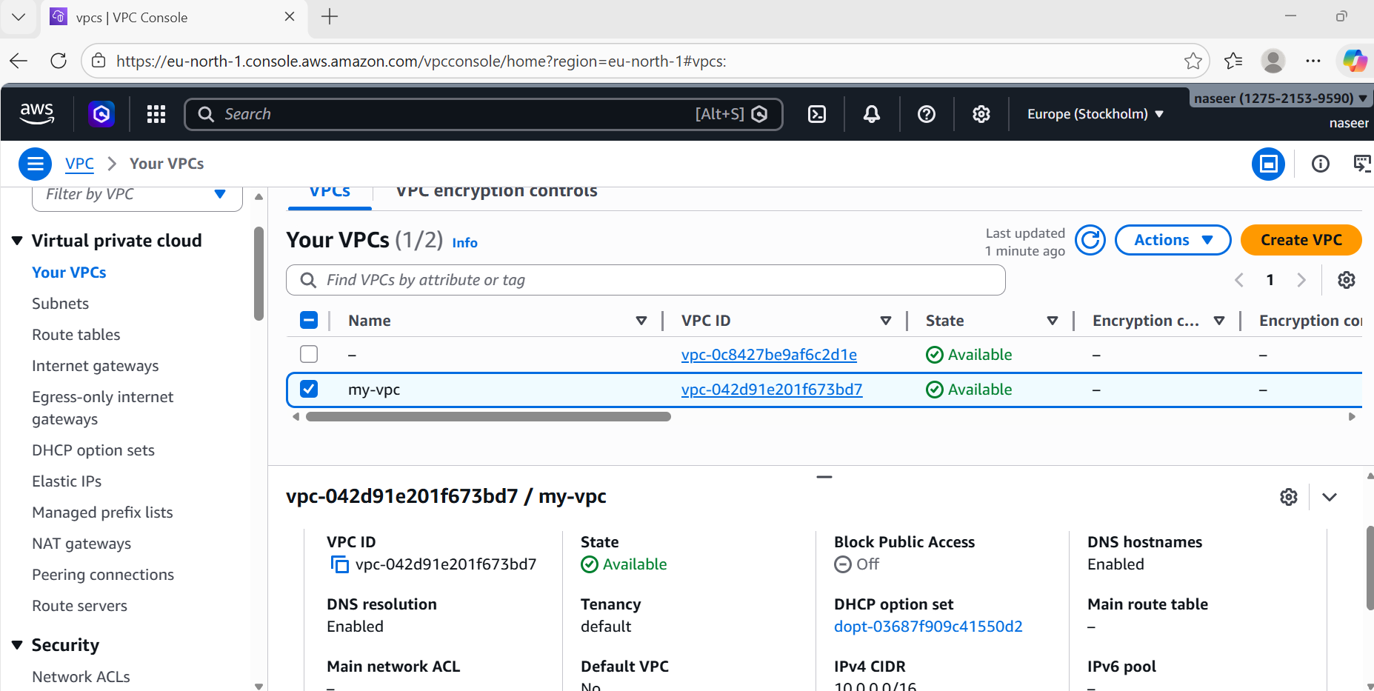

- Enable Auto Assign Public IP in 2 public subnets.
Login into AWS and Navigate to VPC and click on subnets select one subnet and click on actions, edit subnet settings and enable auto-assign public IP
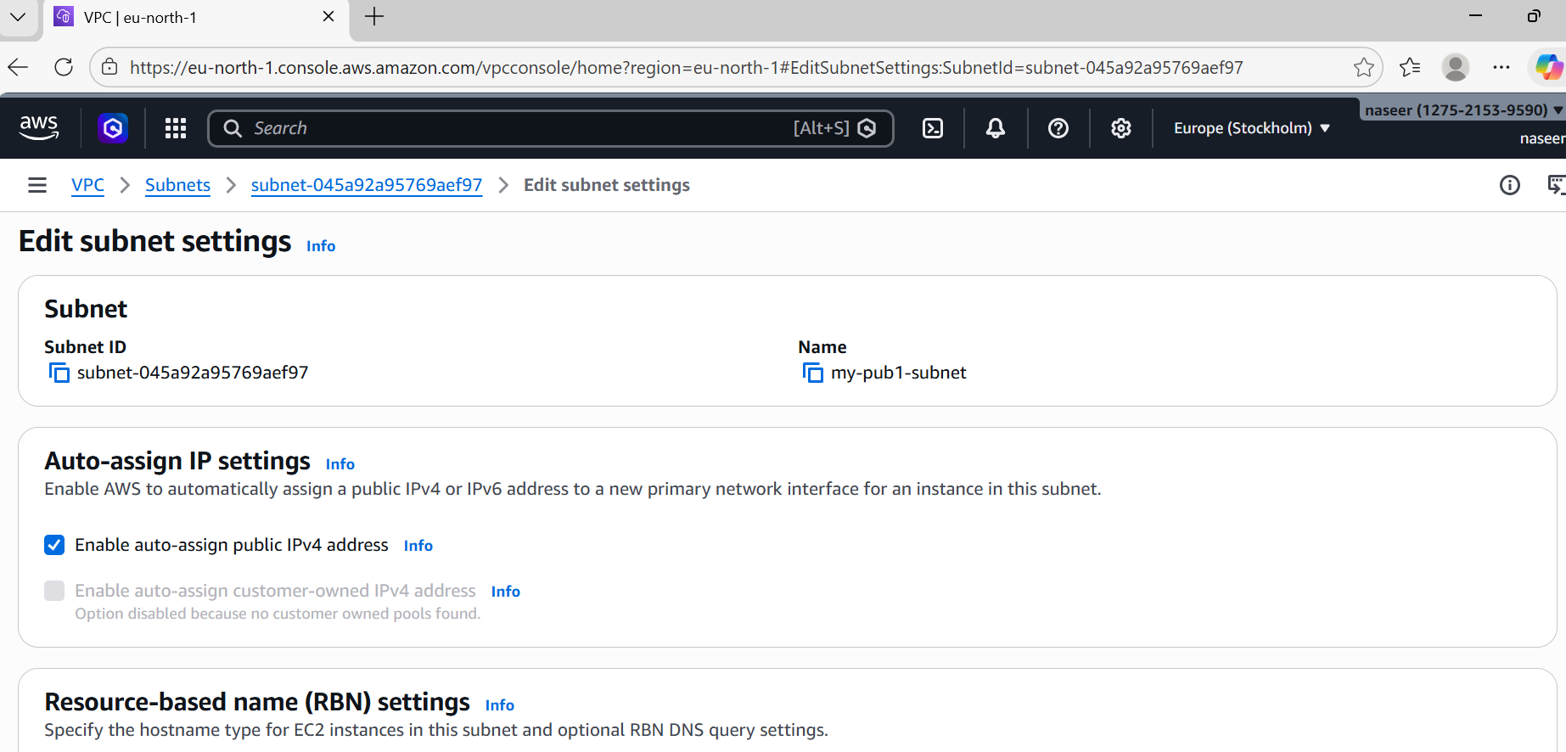

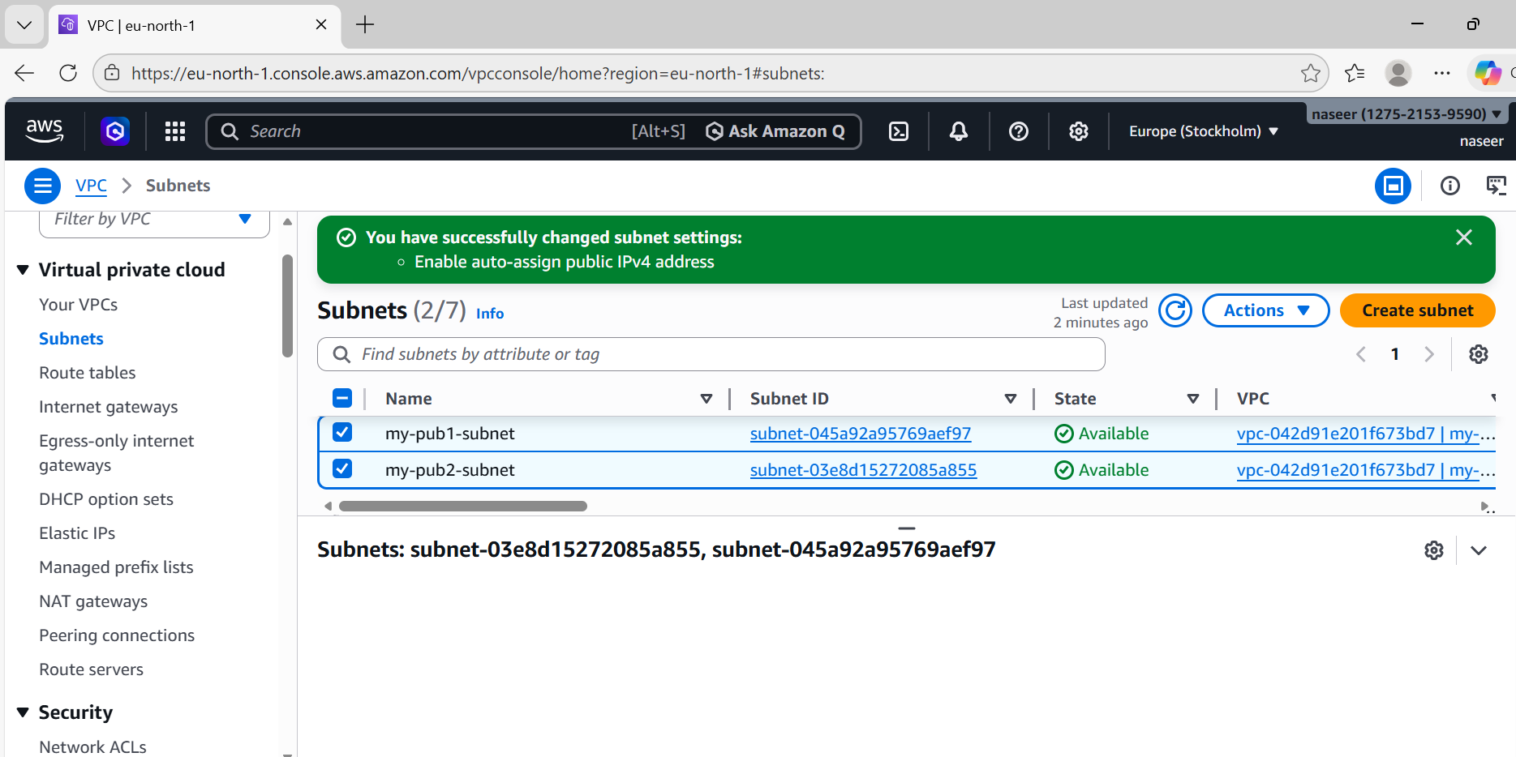

- Add 2 private subnets in private route table.
Log in into AWS account and Navigate to VPC and select Route table, create route table give a name and select we created Vpc and click on create route table.
Select we created route table and click actions edit subnet associates and select 2 private subnets and click on save associates.
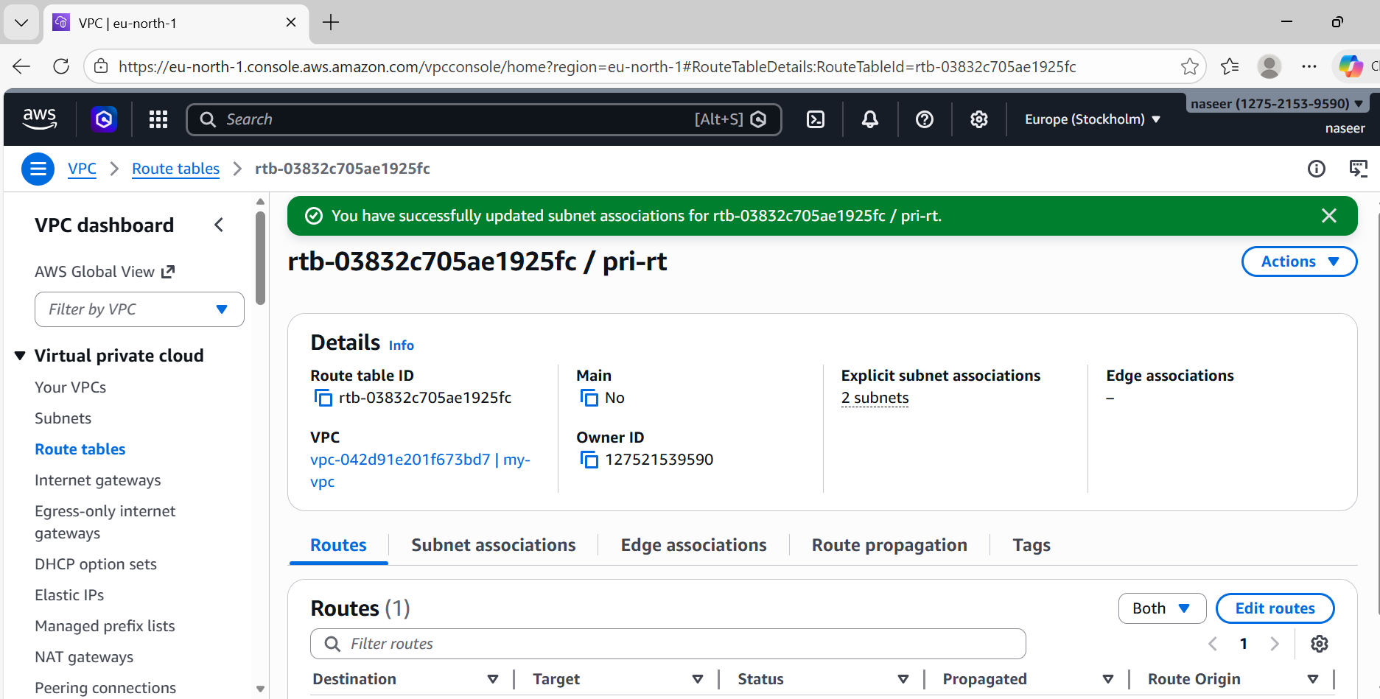

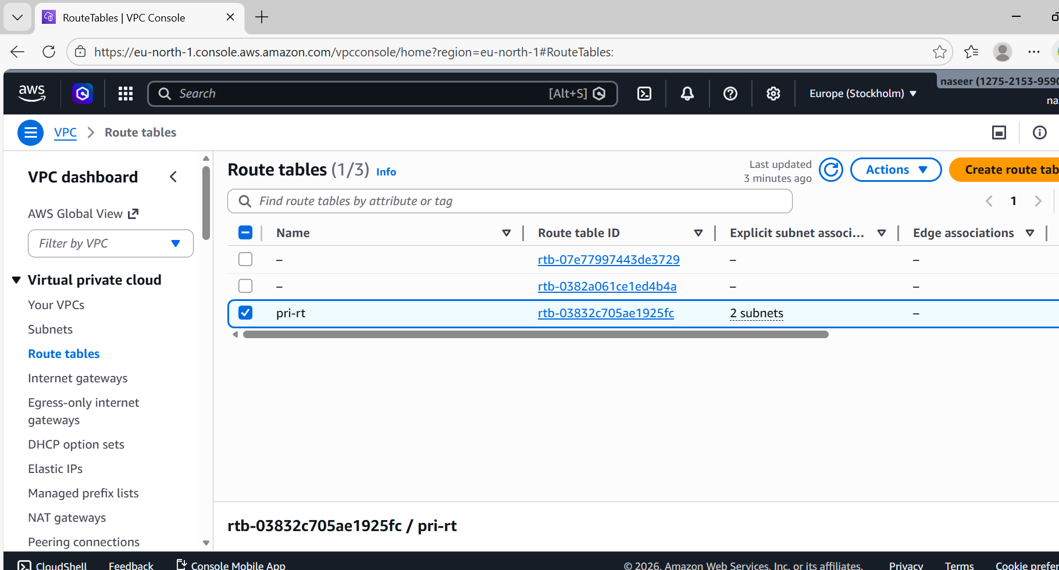
- Add 2 public subnets in public route table.
Log in into AWS account and Navigate to VPC and select Route table, create route table give a name and select we created Vpc and click on create route table.
Select we created route table and click actions edit subnet associates and select 2 public subnets and click on save associates.

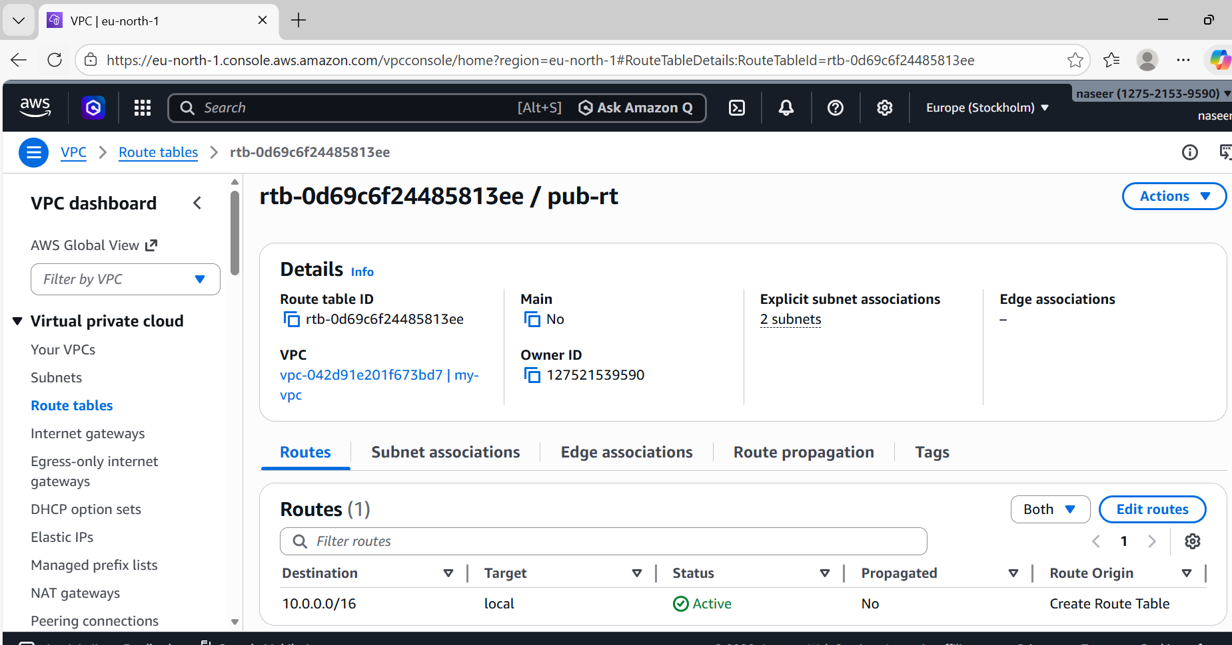

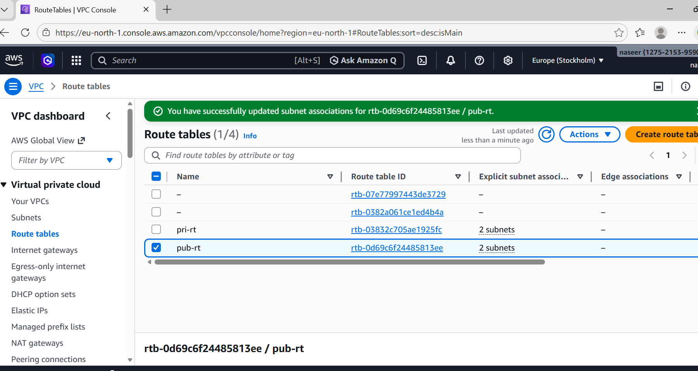
- Public route table will have the routes to internet and local.
Login into AWS and Navigate to VPC and click on Internet Gateways (IGW) select create internet gateways, give name and save.
Select created internet gateway click on action and select attach to Vpc and select created vpc, and select attach internet gateway.
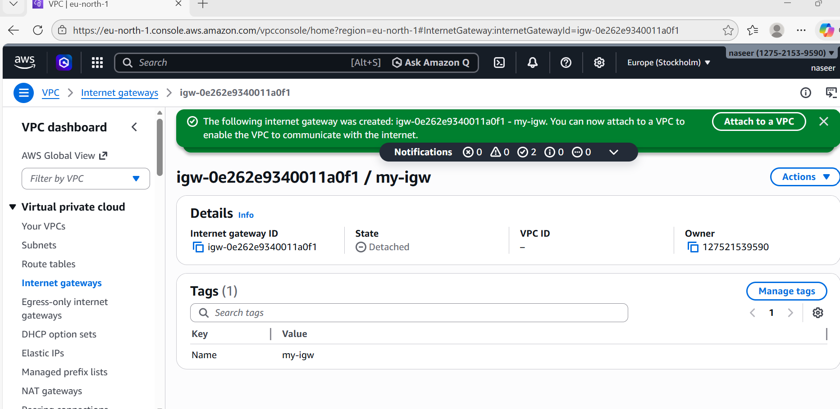

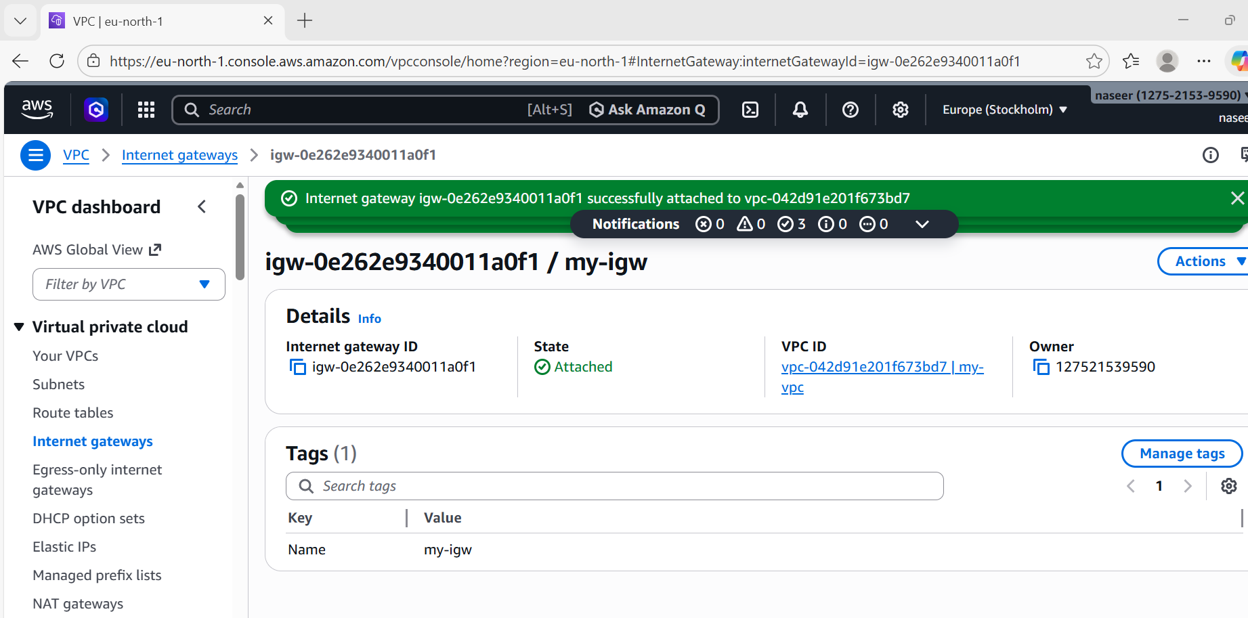
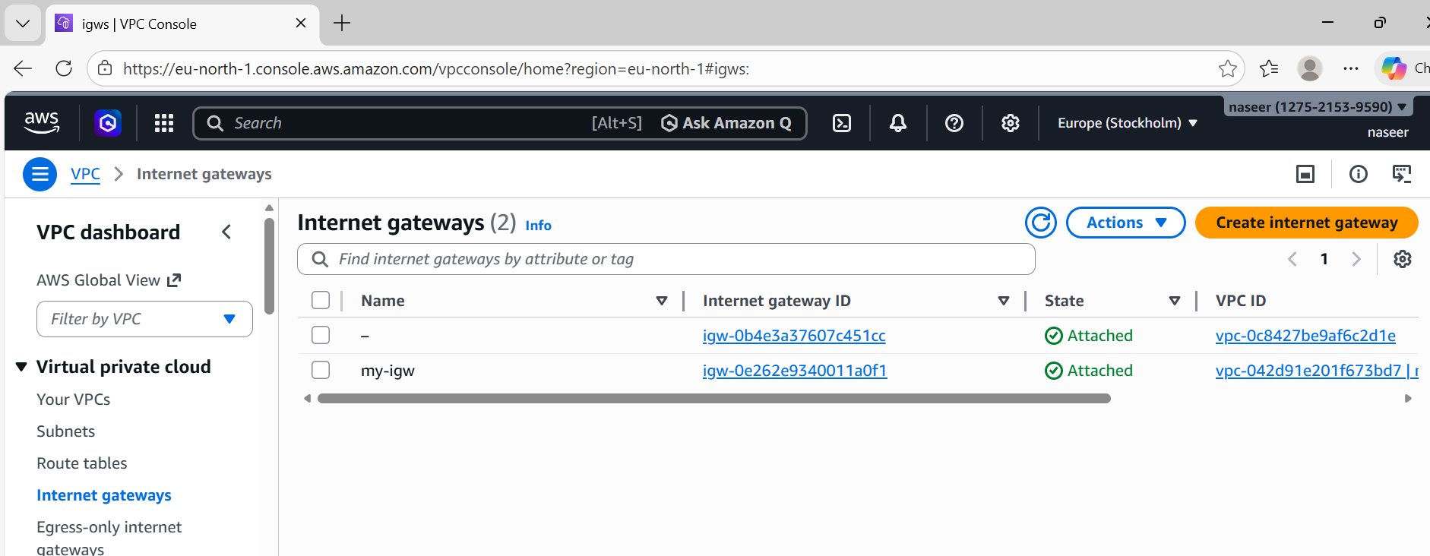
- Create EC2 in public subnet with t2. micro and install PHP.
Launch a instance. Open git bash using pem key and clone with ssh
Sudo su –
Sudo yum update -y
Sudo yum install httpd php -y
Sudo systemctl start httpd
Sudo systemctl enable httpd
Sudo systemctl status httpd

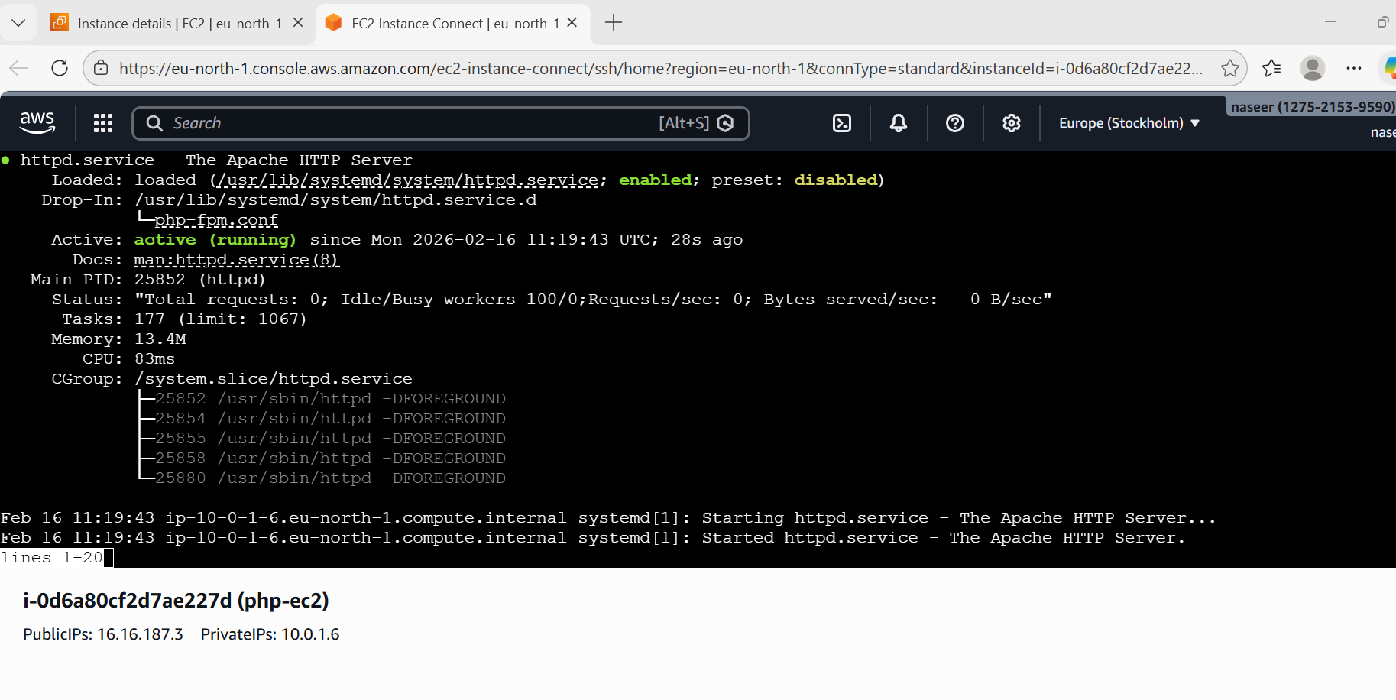
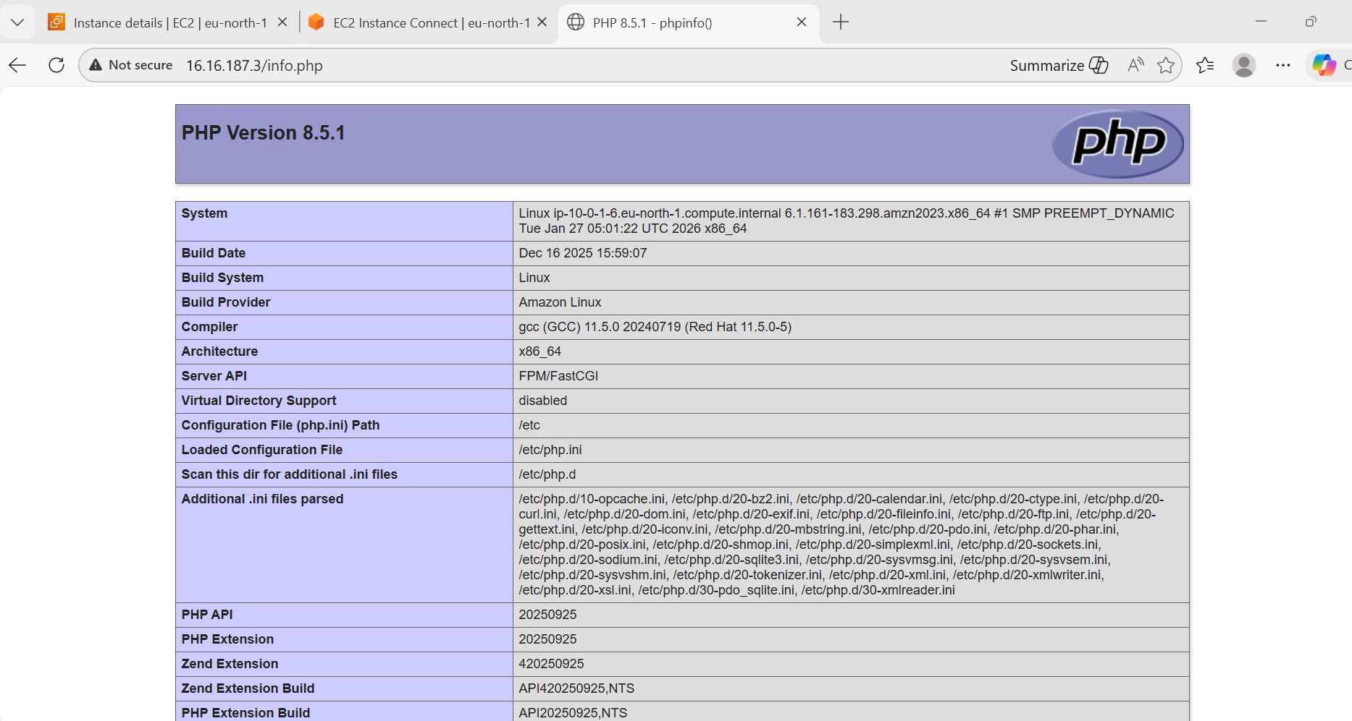
- Configure NAT gateway in public subnet and connect to private instance.
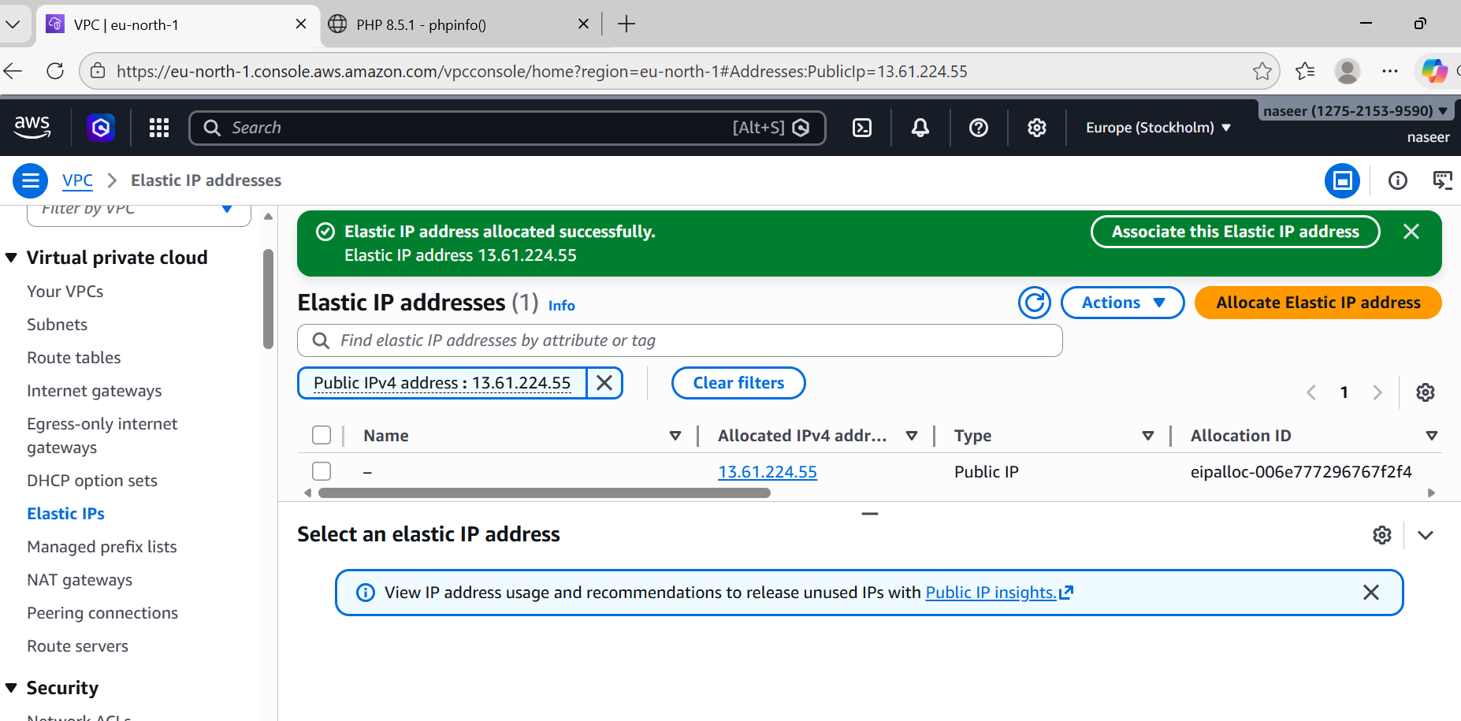
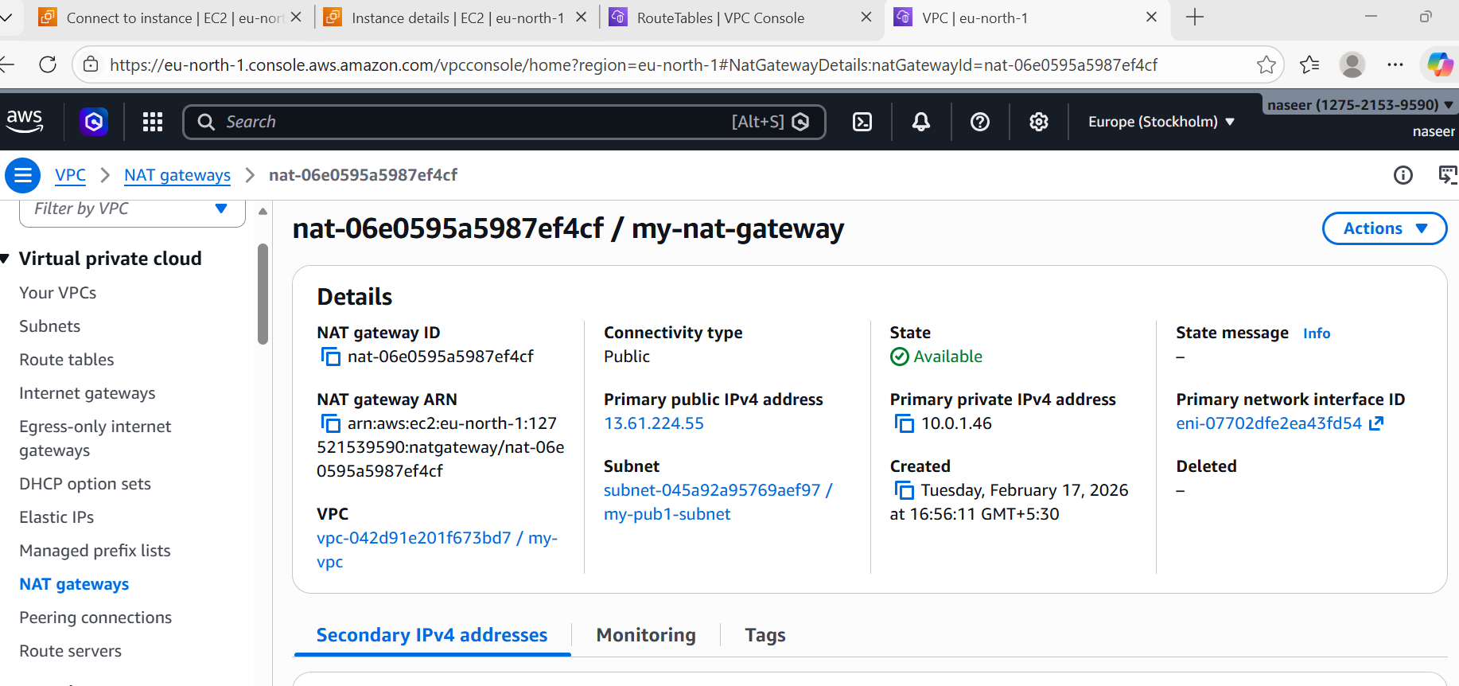

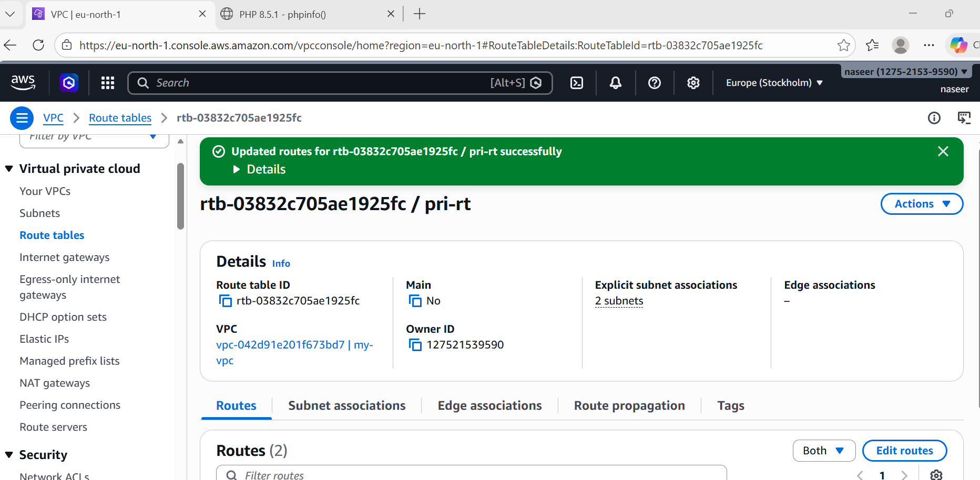
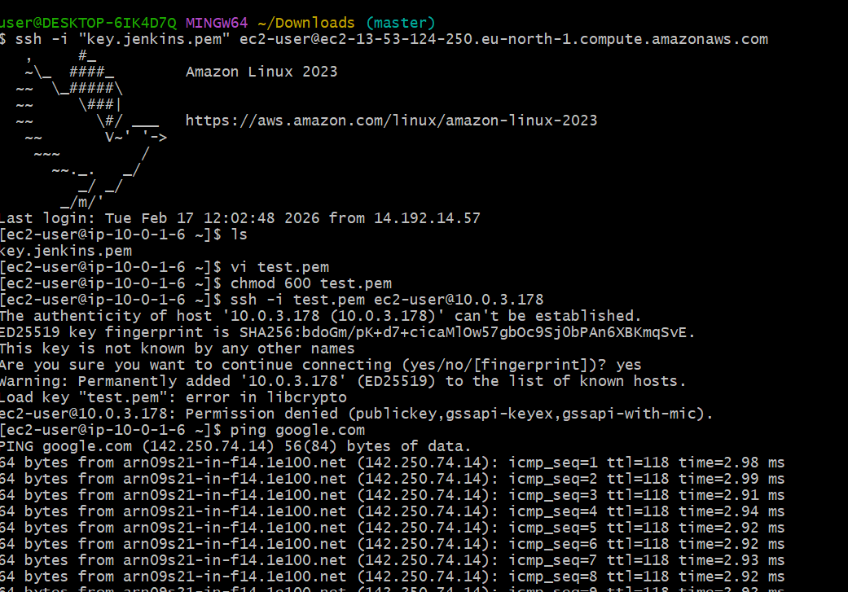
- Install Apache Tomcat in private EC2 and deploy a sample app.
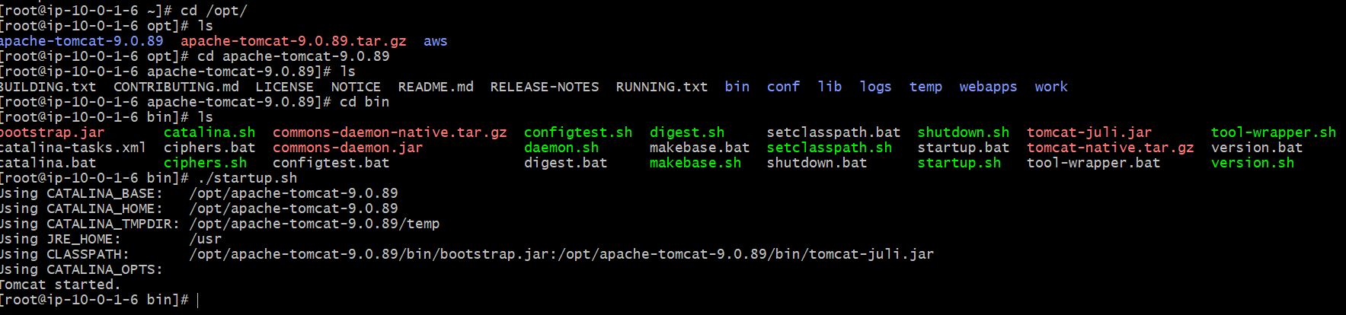
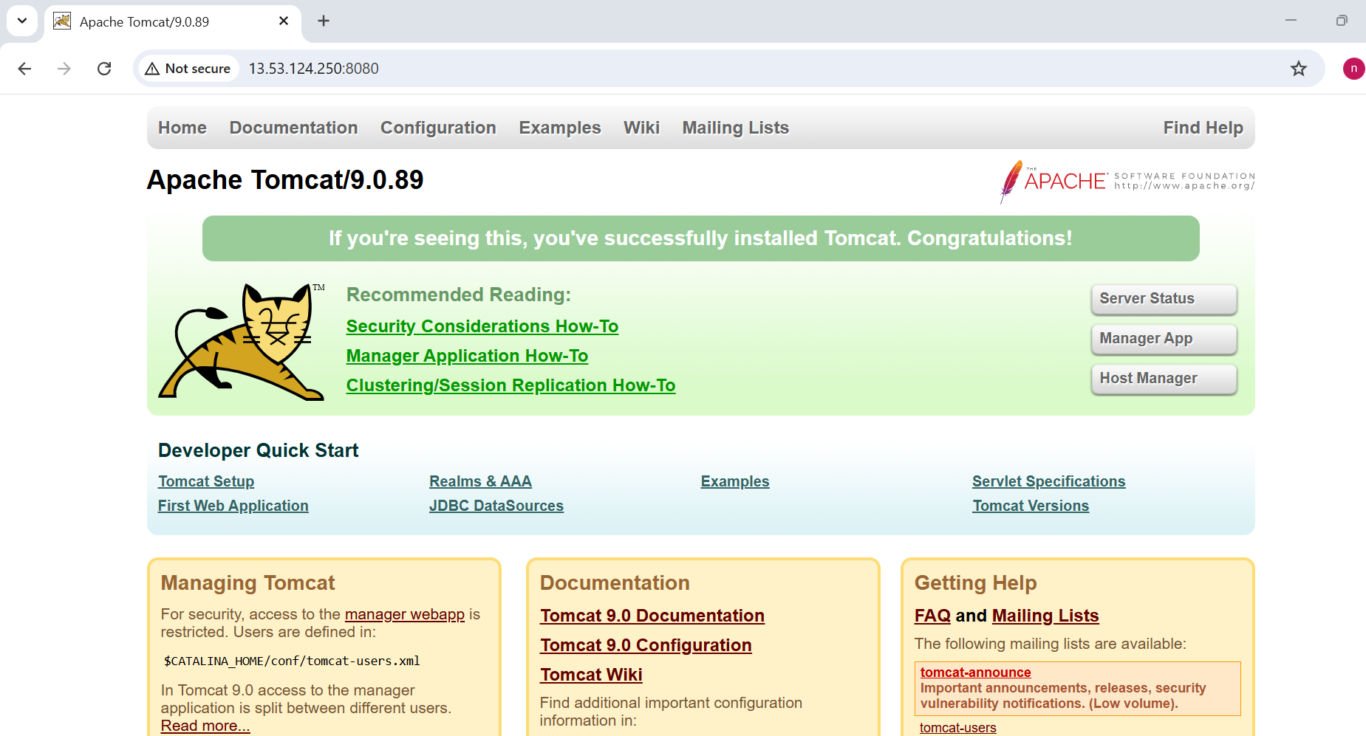
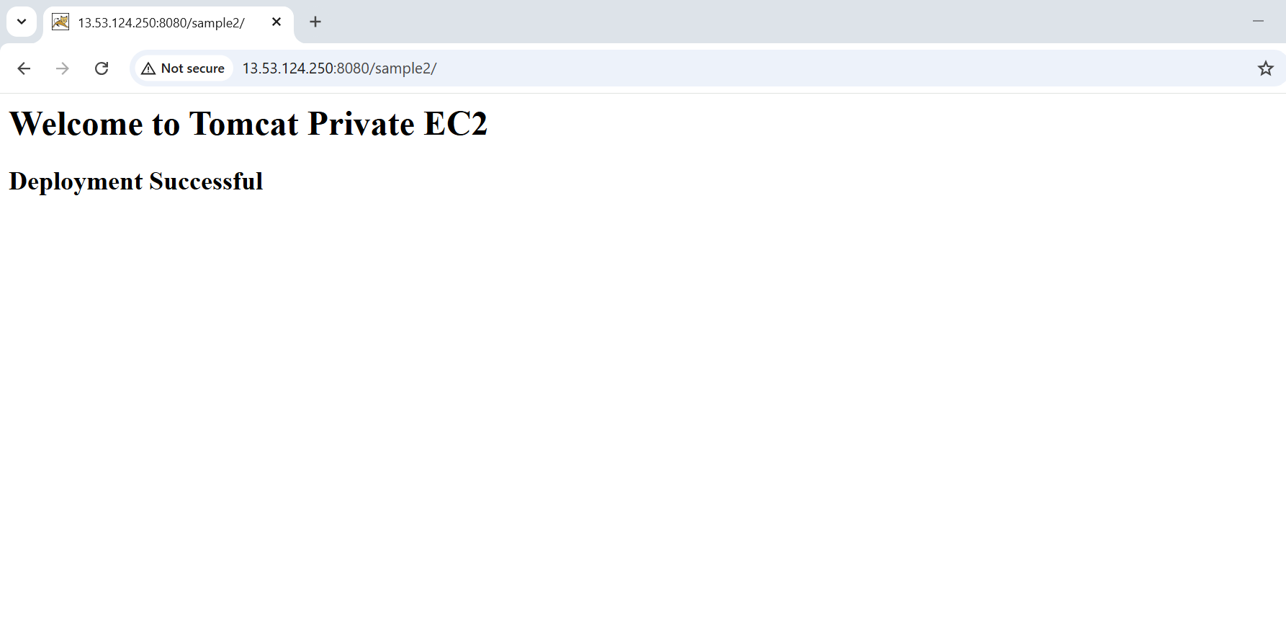

- Configure VPC flow logs and store the logs in S3 and CloudWatch.
